Year of Death

A single number may be concluded based on statistical measure to calculate one expected age of living, if it is accurate, would one want to know how long will one last? Life expectancy refers to the number of years a person is expected to live based on the statistical average. It varies by geographical area and also era. For example, in the Bronze Age, which was the start of many epidemic of infectious diseases, life expectancy was 26 years, while based on the Global Burden of Disease studies of statistics, in 2010, it was at least 67 years.

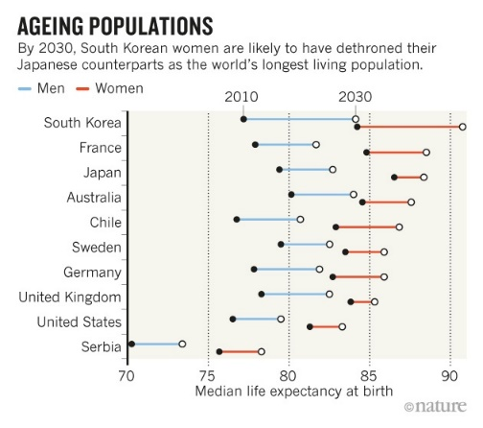

Figure 1 Median Life Expectancy Example.

Source: <https://nature.com/news/>

Life expectancy is a statistical calculation of the average time in years an organism is expected to last or live, based on the year of birth, the current age and other demographic factors. Life expectancy at birth or widely known as LEB, is the most commonly used measure of life expectancy, which could be defined in two different ways; while cohort Life Expectancy at Birth is the mean length of life of an actual birth cohort, with all individuals born a given year, and can be computed only for cohorts born decades ago, in which all their members died, while period Life Expectancy at Birth is the mean length of life of a hypothetical cohort assumed to be exposed since birth until death of all their members to the mortality rates observed at a given year.

In mathematical terms, life expectancy is the mean number of remaining years of life at a given age, assuming age-specific mortality rates remains at their most recently measured levels, and is denoted by *ex*, which means the mean number of subsequent of years of life for organism aged *x*, based on a particular mortality experience. Longevity, maximum lifespan, and life expectancy are not the same thing, are not synonyms. Life expectancy is defined statistically as the mean number of years remaining for an individual or a group of people of a given age. While longevity refers to the characteristics of the relatively long life span of some members of a population. Whilst, maximum lifespan is the age at death for the longest lived individual of an organism. Moreover, as life expectancy is an average, a particular individual may die many years before or many years after the “expected” time. The term maximum lifespan, has different meaning and is more related to longevity than life expectancy.

Life expectancy is widely used in plant and animal ecology, life tables or also known as actuarial tables. The term life expectancy may also be used in a context of manufactured objects, as the term itself known as shelf life which is used to defined consumer products, and the terms mean time to breakdown or MTTB and mean time between failures or MTBF are used in engineering.

According to *The Lancet*, published on December 18, the study, national Life Expectancy at Birth figures reported by the statistical national agencies and international organizations are indeed estimates of period Life Expectancy at Birth. In Bronze and Iron Age, Life Expectancy at Birth were calculated about 26 years, while in 2010, the world Life Expectancy at Birth was 67.2 years. For comparison, in recent years, Swaziland Life Expectancy at Birth is approximately 49 years, while in Japan, it is about 82.6 years. This can be caused by the combination of high infant mortality and deaths in young adulthood from accidents, epidemics, plagues, wars and childbirth, particularly before the invention of modern medicines was widely available which significantly lowers the Life Expectancy at Birth.

Even though environmentally unstable, for those who survive the early hazards, a life expectancy of estimated 60 to 79 is not uncommon. For example, a sample of society with a Life Expectancy at Birth of 40 may have few people dying at precisely 40, while most will die before 25 or after 55. In populations with high infant mortality rates, Life Expectancy at Birth is highly sensitive to the rate of death in the first few years of life. This sensitivity to infant mortality might cause Life Expectancy at Birth to be subjected to gross misinterpretation, leading one to believe that a population with low Life Expectancy at Birth will necessarily have a small proportion of older people. In a given sample, in a hypothetical stationary population in which half the population dies before the age of five but everybody else dies at exactly at 70 years old, the Life Expectancy at Birth will be about 35, but about a quarter of the population will be between the ages of 50 and 70. In another measure, such that a life expectancy at age 5 (*e5*), can be used to exclude the effect of infant mortality to provide a simple measure of overall mortality rates other than in early childhood, as the hypothetical population above, life expectancy at 5 would be another 65. With aggregate population measures, such that the proportion of the population in various age groups, should also be used along individual based measures life formal life expectancy whilst analyzing population dynamical structure.

The first step in calculating life expectancy is the age specific death rates of the population members. When a large number of data is available, then a statistical population can be created that may allow the age specific death rates to be considered as the mortality rates experienced at each age, as the number of deaths divided by the number of years exposed to risk in each data cell. But, it is mandatory to smoothing to iron out as much as possible the random statistical fluctuations from one year of the age to the next. In the past, a simple model was used for this purpose, which is the Gompertz function.

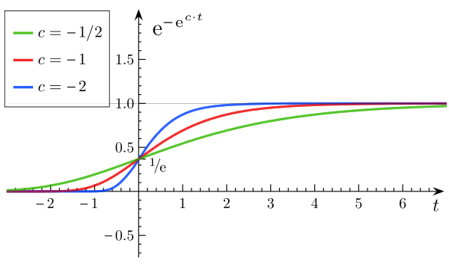

Figure 2 Example of Gompertz Function.

Source: <https://statisticshowto.com/>

There are 3 different common methods used nowadays as the evolution of the function to serve the above purpose, which is; to fit a mathematical formula, such that the extension of the Gompertz function to the data. For a relatively small amount of data, utilizing the mortality table that was previously derived from a larger population with some simple adjustment to it by multiplying it with a constant factor to fit the data. Lastly, with a larger amount of data, one may look at the mortality rates which is actually experienced at each age by applying smoothing.

Data required can be easily identified in the case of humans, while the computation of life expectancy of an industrial products and wild animals involves more indirect techniques. The life expectancy and demography of wild animals were often calculated by capturing, marking and also recapturing the animals. The life of a product which also defined as shelf life, is also computed by using similar methods. In the case of a long lived components such critical applications, like in aircraft, methods such as accelerated aging are used to model the life expectancy of a component.

An age specific death rates are calculated separately for separate groups of sample which is believed to have different mortality rates, such that males and females, or perhaps smokers and nonsmokers, are used to calculate a life table from which one can calculate the probability of surviving at each age. With actuarial notation, the probability of surviving from age *x* to age *x* + *n* is denoted as *nPx*, while the probability of dying during age *x* between the ages of *x* and *x* + 1 is denoted as *qx*. As an example, if 5% of a group of people alive at their 90thbirthday dies before their 91st birthday, then the age specific death probability at 90 would be 5%, thus it’s a probability, not a mortality rate. The expected future lifetime of a sample age *x* in whole years or the “curtate” expected lifetime of *x* is denoted by the symbol ex. It is the conditional expected future lifetime in years, assuming survival to age *x*. if K(*x*) denoted as the curtate future lifetime at *x* then;

*e*x= E[K(x)] = *kPx qx+k*.

The equation can be simplified into:

*e*x= x.

By substituting *kPx qx* + k with *kPx – k+1Px* in the sum formula, with the assumption that on average, people live a half year in the year one deaths, with the complete expectation of the future life time at age *x* is *ex* + 0.5.

Basically life expectancy is an arithmetic mean, which can also be calculated by integrating the curve of the survival from 0 which span to positive infinity, or so called the maximum lifespan or omega. In the case of extinct or complete cohort, people born in the year 1800’s for example, it can be simply calculated by averaging the ages at death. For cohorts with some sample of survivors, it is estimated by using the mortality experience of that years. This estimation are so called period cohort life expectancies. It is important to note that the statistic is usually based on past mortality experience, that assumes the same age specific mortality rates will continue into the future, and not using the current one. Thus, such estimation of life expectancy figures need to be adjusted for temporary trends before calculating the life time of an individual of a particular age is expected to live. Period life expectancy remains as a commonly used statistic to summarize the current health status of a population. In some cases, such that pensions calculations, usually assuming the age specific death rates will continue to decrease over the years is used to adjust the life table. It is often done by interpolating past trends, with some models exist to account for the evolution of mortality, such as Lee-Carter model.

P(T > t) = α1 + (α2 – α1)

In the alpha mention statements above, regarding the factors that may affect one’s life, are associated with variations in life expectancy, which includes family history, marital status, economic status, physique, exercise, diet, drug use which includes smoking and alcohol consumption, disposition, education, environment, sleep, climate and health care. As far as assessing the normal or intended life expectancy, according to the World Health Organization, it is published in 2001 called Healthy Life Expectancy or so called HALE, which defined the average number of years one can expect to live in the fullest by excluding the years lived in less than full health due to disease or injury. While Eurostat, starting 2004 has published annual statistics regarding the issue called Healthy Life Years or so called HLY based on reported activity limitations. In the United States, they use similar indicators in the framework of the national health promotion and disease prevention plan in 2010, called Healthy People. These estimations or so called calculations are used by many to monitor the health of the population.

As mentioned above, life expectancy differs from life span itself. Life expectancy refer to the average computed over all people, including those which die shortly during birth, shortly after childbirth, during adolescence or adulthood, those who die in war and those who live well into old age, while lifespan is an individual specific concept, with maximum lifespan acts as an upper bound rather than an average. A number of factors such as mentioned before, influence life expectancy including gender, race, exposure to pollution, education status, race, income level and healthcare access. Modifiable lifestyle factors such as exercise, alcohol consumption, smoking status and diet influence life expectancy. Therefore, in one hand, life expectancy is a highly variable from one individual to another.

Lifespan, on the other hand, refers to the maximum number of years that one can potentially expect to live based on the greatest number of years anyone from the same population or data set has lived. While these two terms differs from each other, it is often confused as the same thing. For example, citing from Distance Healing to Vitamin O by Christopher Wanjek, evidence recently discovered that indicates St. Germain may have been the long lost third son of Rakoczi, which born in Transylvania in 1694. If he died in Germany in 1784, he have lived for 90 years, while the average life expectancy in the 18thcentury was 35 years. These numbers may not be so accurate, such that one could survive pass the life expectancy, for example a Frenchmen, Jeanne Calment, has been known to live for 122 years. It is often argued that comparing period life expectancy after childhood is better to get a handle on life span. It is because life expectancy could change drastically pass childhood, as demonstrated in the Roman Lifestyle Expectancy Table, whereas at birth, the life expectancy was 21, but by the age of 5, the life expectancy rose to 42. Other studies such as *Dead at Forty* and *Plymouth Plantation*, have also demonstrated the significant jump in life expectancy that’s predicted after adulthood compared to childhood ages.

Knowing how inaccurate the calculation is, it is often used for population control, but again, if these estimation turns into facts or certainty, would one like to know, how long will one last?